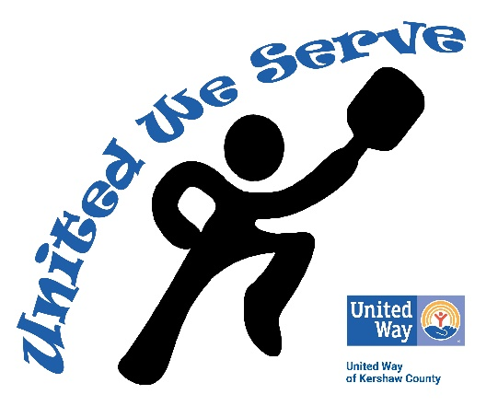

Please consider becoming a sponsor for the 2019 United Way of Kershaw County Pickleball Tournament!

Check out the results of our first “United We Serve” tournament in the newspaper articles and video footage attached and you will see why your company will benefit from the exposure you will have in our Year Two Tournament scheduled for April 5TH through the 7TH. Participants from five states and across South Carolina gave rave reviews, promised to return and bring their friends. A representative from the national Pickleball Tournament Association agrees that we will more than double in 2019.

United Way of Kershaw County’s Pickleball Tournament will be held April 5th, 6th and 7th, 2019. The tournament will feature men’s, women’s and mixed doubles and will take place at the beautiful, new Camden Classically Carolina Tennis Complex, 823 Campbell Street, Camden. Snacks, drinks and t-shirts will be provided to participants throughout the event as well as a lunch on Saturday.

Proceeds will benefit the United Way of Kershaw County’s Health and Hunger initiatives to fight hunger in our community.

Make certain your company does not miss out on the publicity gained during this exciting event! Visit www.uwkc.net for sponsorship information and for registration inquiries email pmaoli@camdensc.org.

